Guided Capstone Project Report
Nov 7, 2026 · @Ajanay Squire

Summary
Big Mountain Resort charges $81 for an adult weekend ticket, but its facilities support a price of about $95.87 when compared with similar resorts. We recommend raising the price gradually, going ahead with the new chair lift as part of a run-and-lift upgrade (Scenario 2), and trialling the closure of one little-used run.

Problem statement
Big Mountain Resort in Montana has just installed a new chair lift. The lift adds $1,540,000 a season in operating costs. The resort currently sets its ticket price by charging a premium over the average of resorts in its market, without knowing which of its facilities customers actually value.
The question: what ticket price do Big Mountain's facilities support, and which changes (closing runs, or adding runs, lifts and snowmaking) would raise revenue or cut costs? The resort expects about 350,000 visitors a season, each buying around 5 day tickets.

Data wrangling
The raw data described 330 US ski resorts in 27 columns: their size, lifts, runs, snowfall, season length and ticket prices. Big Mountain was in the data with no missing values, charging $81 on both weekdays and weekends. Cleaning left 277 resorts and 25 columns:
- 51 resorts with no weekend ticket price were removed, since price is what the model predicts.
- The weekday price was dropped. Weekend prices had fewer gaps, and every Montana resort charges the same for both.
- Two clear errors were handled. Silverton Mountain's skiable area of 26,819 acres was a typo for 1,819 and was corrected. A resort listed as open for 2,019 years was removed.
- The fastEight lift column was dropped. Half its values were missing and all but one of the rest were 0.
- State population and land area were added from Wikipedia, so each resort could be placed in its local market.

Exploratory data analysis
The state a resort is in does not predict its ticket price. States differ a lot: New York has the most resorts, Colorado the most skiable area, and Vermont and New Hampshire the most resorts per person. But when states were grouped by these features, expensive and cheap states appeared all over the chart (Figure 1).
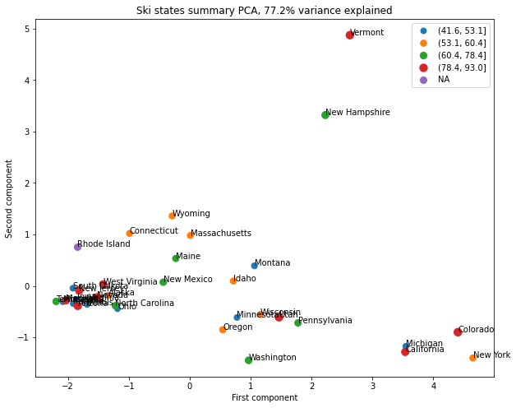
Figure 1. Each dot is a state, placed by its ski market features (number of resorts, skiable area, resorts per person and per square mile). Colours show average ticket price. High-price states (red) sit in every part of the chart, so state alone doesn't explain price.
So all resorts were modelled together, with state captured through market features such as a resort's share of its state's skiable area. Facilities mattered far more: ticket price rose with vertical drop, number of runs, fast quad lifts, total chairs and snowmaking area.

Preprocessing and models
Preparing the data. Big Mountain was set aside so the model learned only from other resorts. The rest were split 70/30 into training and test sets. Missing values were filled with each column's median, features were put on a common scale, and new features were added, such as chairs per run and each resort's share of its state's facilities.
How models were scored. The main measure was mean absolute error (MAE): how many dollars, on average, a predicted price is off from the real price. Each model was checked with 5-fold cross-validation (testing on five different slices of the training data) and then on the held-back test set.

Model | Average error, cross-validation | Average error, test set
Guessing the average price for every resort | — | $19.14
Linear regression (best 8 features) | $10.50 (± $1.62) | $11.79
Random forest (69 trees, median fill, no scaling) | $9.64 (± $1.35) | $9.54
The random forest won: it was about $1 more accurate, varied less between slices, and its test result matched its cross-validation estimate. Its most important features were fast quads, runs, snowmaking area and vertical drop (Figure 2). A learning curve showed accuracy levels off after about 40–50 resorts, so more data is unlikely to help much.
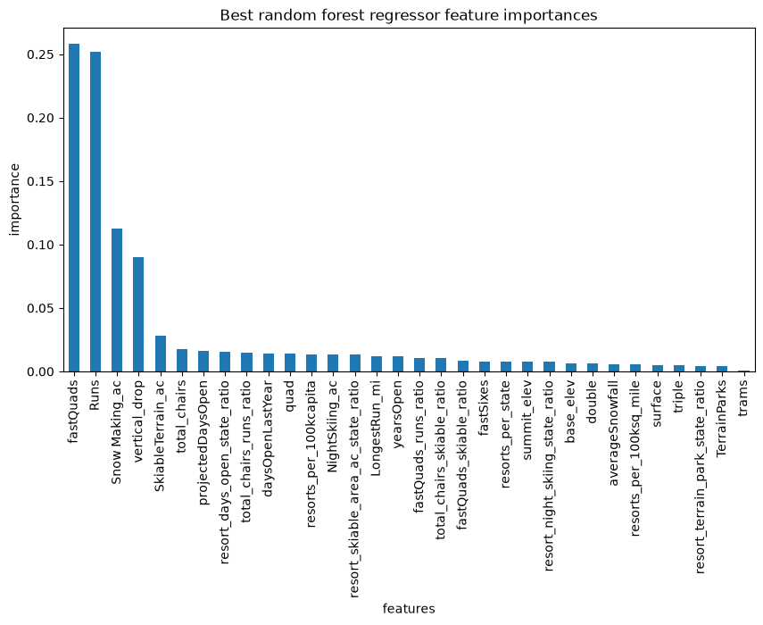
Figure 2. How much each feature contributed to the random forest's price predictions. Four features stand out: fast quads, runs, snowmaking area and vertical drop.

Winning model and scenario modelling
Retrained on all 276 other resorts, the random forest puts Big Mountain's price at $95.87, against its actual $81. That gap is wider than the model's typical error of $10.39. Big Mountain already charges more than most resorts (Figure 3), but it ranks near the top for vertical drop, snowmaking, chairs, fast quads, runs and skiable area.
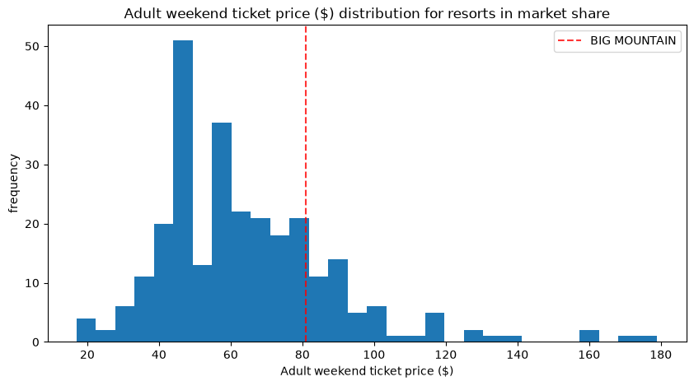
Figure 3. Adult weekend ticket prices across all resorts. The red line marks Big Mountain's current $81.
Four scenarios were tested by changing Big Mountain's facilities and asking the model for the new price:
Scenario | Change in supported price | Change in season revenue
1. Close up to 10 of the least-used runs | $0 for 1 run, down to −$1.81 for 10 | $0 to −$3.2M
2. Add a run, 150 ft more vertical drop and a chair lift | +$1.99 | +$3.47M
3. Scenario 2 plus 2 acres of snowmaking | +$1.99 (no extra gain) | +$3.47M
4. Lengthen the longest run by 0.2 miles, add 4 acres of snowmaking | $0 | $0
Revenue assumes 350,000 visitors each buying 5 tickets. Closing one run costs nothing in price, but losses grow in steps after that (Figure 4).
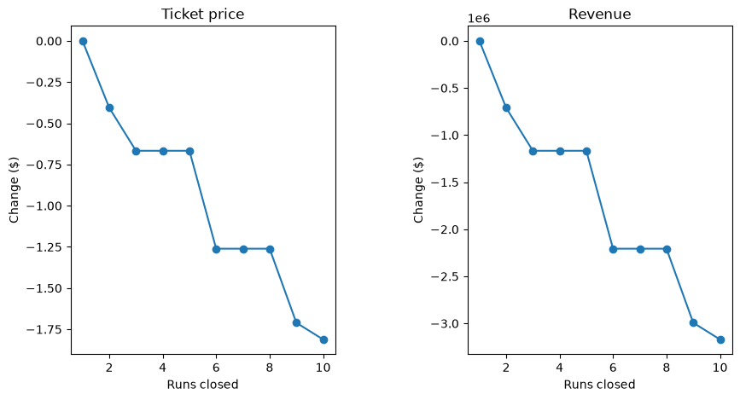
Figure 4. Predicted change in ticket price (left) and season revenue (right) as 1 to 10 runs are closed. The first closure costs nothing; 2–3 closures lower the price, 4–5 add no further loss, and 6 or more cause a bigger drop.

Pricing recommendation
- Raise the ticket price gradually toward the model's $95.87, rather than all at once, and watch ticket sales and customer feedback after each step. The model assumes other resorts price correctly and cannot see how Big Mountain's own customers would react.
- Cover the new chair lift easily. Its $1,540,000 cost spread over 1,750,000 tickets is about $0.88 per ticket.
- Go ahead with Scenario 2. It supports $1.99 more per ticket, about $3.47M a season, more than double the chair lift's cost.
- Trial closing one little-used run for a season, since the model shows no loss in price. Track visitor numbers and sales before closing any more.

Conclusion
Big Mountain appears to be undercharging for what it offers. A gradual price rise, combined with the Scenario 2 upgrade, could add several million dollars a season, more than covering the new chair lift. Extra snowmaking and a longer run (Scenarios 3 and 4) did not add value and are not recommended.

Future scope of work
- Collect better data: visitor numbers, operating costs for each lift and run, and revenue beyond tickets (passes, lodging, food, rentals). This would let the model measure profit, not just price.
- Ask leadership why the price is $81. If it was set low on purpose, the model's figure may need to be weighed against that strategy.
- Make the model easy to use. A simple web app or dashboard would let business analysts try their own scenarios without needing a data scientist.
- Retrain the model regularly as new resort data comes in.

